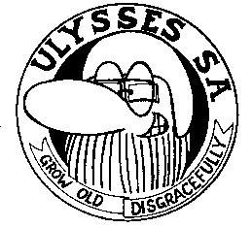
JO.BURG SOUTH

NEWSLETTER JULY 2015
Meeting was chaired by Frik, absent were Santa, JJ, Elsie & Ray (in USA), Stui and
Tony (not well) Ray C (faaar away) and Sharm (down by the sea in PE)
Was a short meeting, unusually calm and peaceful. June meeting did not happen,
as we had our Hobo farewell for Sharm, went off splendidly. Pics are on the club
notice board.
The raffle for the welder, plus welding helmut will take place at the August meeting.
Remember to bring outstanding raffle lists.
We have a spray gun that will be raffled at a future date.
The memorial for Peter Raubenheimer on Sunday went well, and the run and brekkie
was enjoyed by all.
Finance: At the end of July meeting was standing at R 2,703.00, the bar takings
and raffle monies still to be added. Thanks to our Minister of Finance, Gerda.
It was also decided to charge R5.00 per cup for coffee after the meeting, to go to
club finances.
Santa & Japie catered for July - their daughter spoilt us will an awesome lasagna
Ray & Elsie to cater for August
Birthdays for August
03 Tony
05 Jeff
08 Andre
14 Santa
Jeff has invited the club to celebrate his 60th birthday with him on Saturday
8th August at his kia, at 2.00pm. Suppose he expects a birthday gift !!!!
Toy run on 29th November in Benoni.
August meeting 13th

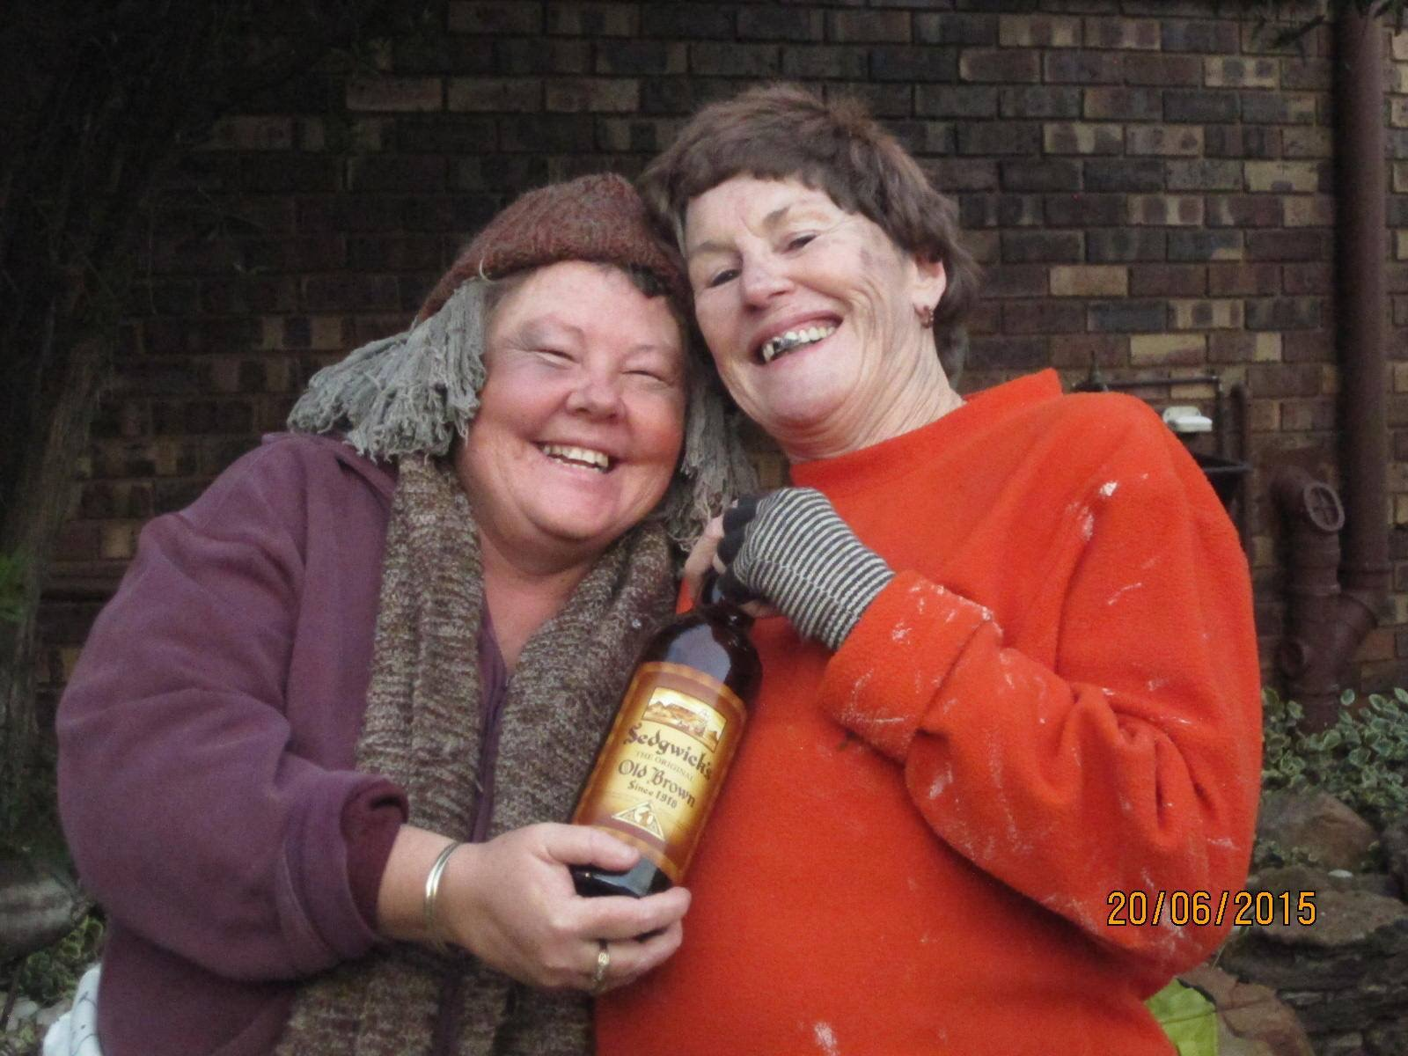
Hard to believe these stunning ladies are our Minister of Finance and secretry !!!!
Cheers
Safe on the roads and keep warm

